DB4o Eclipse Plug In

Introduction

Db4oEclipse is an Eclipse plug in to explore and query the db4o database content.

Currently, the plug-in provides similar functionality as the object manager application.

Features currently implemented are:
- Open a db4o database file
- Connect to db4o database server
- Browse database content
- Define queries

Db4oEclipse provides two views:
- Db4o Explorer View
- Db4o Objects View

The Db4o Explorer View is responsible to load or connect to a database. The content of a db4o databse is displayed in a tree. In the current version the explorer view is also used to define queries on the database.

Db4o Objecst View displays the data of an object or collection depending on the selection made in the Db4o Explorer View.

The following screen shot shows these two views in action.

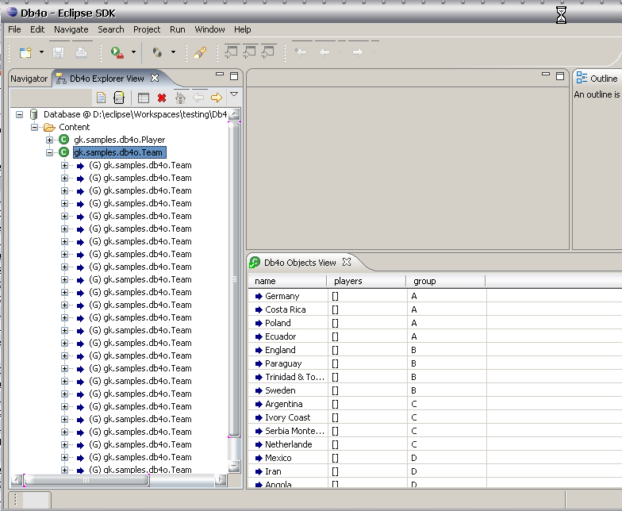

Db4o Explorer View

The Db4o Explorer View is responsible to display and browse a db4o database. The content of a database is presented in a tree with the opened database connection as a root element.

Under the root element a folder item named ‘Content’ indicates the access to the database content. This item contains the stored classes as children.

Below the classes are group all instances of that class. The lowest level displays the properties of the instances including their current values.

The following actions are defined for the explorer view:
- Open a db4o database file
- Connect to db4o database server
- Creating queries
- Deleting queries

Note: in the current version, the view state is not persisted.

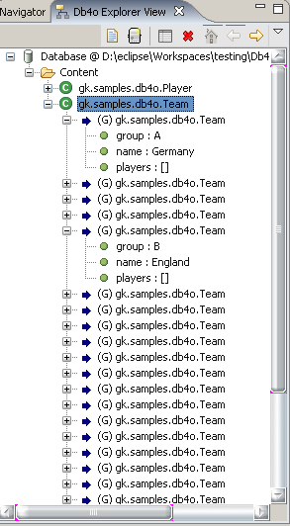

Open a database file

An action to open a database file has been added to the local toolbar and to the context menu of the view.
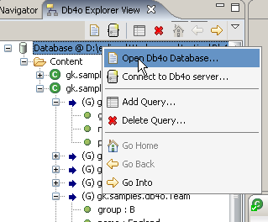

Executing this action opens an open file dialog to select a db4o database file that should be loaded. Selecting a valid db4o database file and pressing the open button, starts reading the db4o database file.

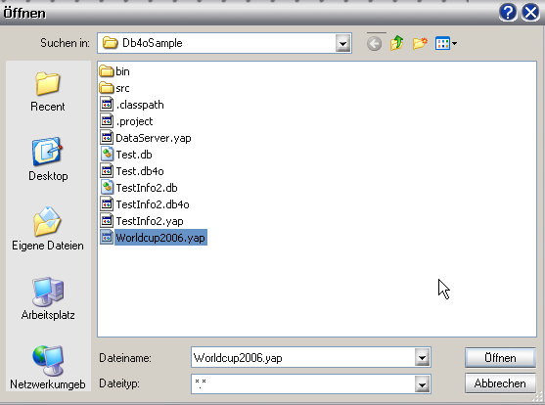

The name of the loaded db4o database is added as the root element to a tree control in the client area of the db4o explorer view.
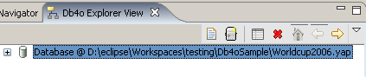
Start exploring the database content from this root element.

Connect to a db4o server
An action to connect to an db4o database server has been added to the local toolbar and to the context menu of the view.

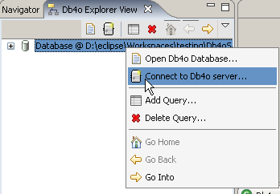

Executing this action opens a dialog to enter the connection details. The connection details are entered as a string. The format is: <host>:<port>:<user>.

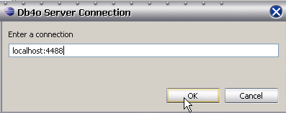

The name of the loaded db4o database is added as the root element to a tree control in the client area of the db4o explorer view.

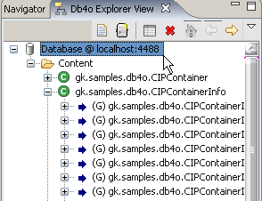

Start exploring the database content from this root element.

Limited data displayed

When exploring the database content, you will notice that not all objects of the database are displayed. Instead, only a limited number of objects are loaded. By default, this value is set to 50, but it may be changed in the preferences dialog.

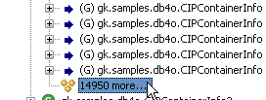

An additional node added to the tree notifies the user about how many objects are still waiting to be loaded. Double clicking on this tree node (or selecting it and pressing enter) reads the next set of objects.

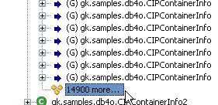

Adding queries
An action has been added to the local toolbar and to the context menu of the view that enables the user to define a simple query on the database.

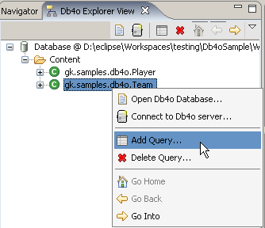

Executing this action opens a dialog to define the query. You can name the query and set the query parameters for a certain type.

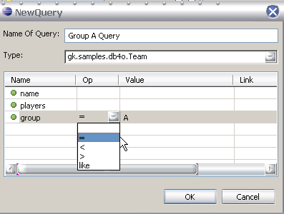

After pressing ok, the query is added to the tree as a separate node on the same level as the content folder node of the opened db4o database.
The number of objects in the resulting object set is appended to the query name.
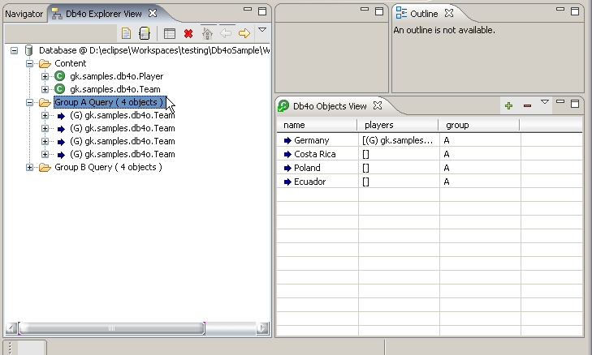

A query can also be deleted by selecting a corresponding action on the local toolbar or the context menu.

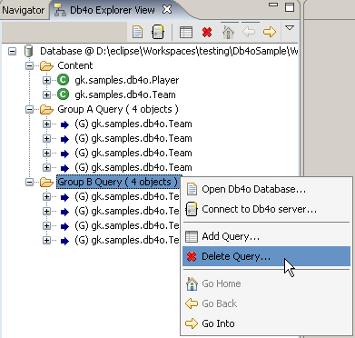

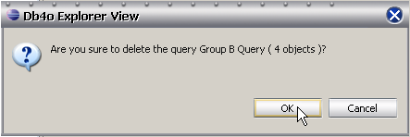

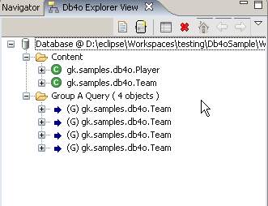

Db4o Object View

Db4o Objecst View displays the data of an object or collection depending on the selection made in the Db4o Explorer View.
Currently, only simple data types are displayed in the columns.

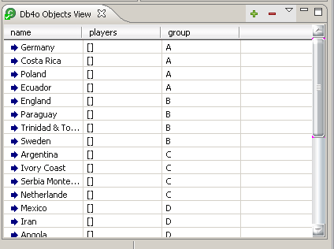

The displayed content in the db4o Object View depends on the selection made in the db4o Explorer View.

Selecting a class

If a type or class is selected, then the properties of all loaded instances of this class are displayed.

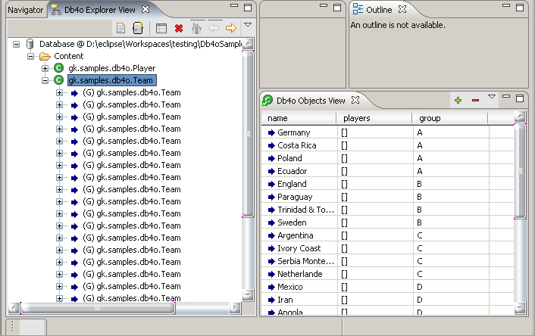

Selecting an object
If an instance of a type or class is selected, then the properties and their values are displayed in a generic way.

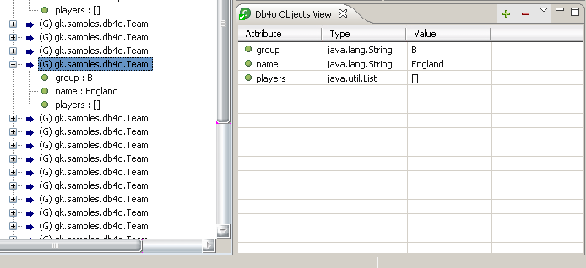

Preferences
Two preference values are defined in db4oEclipse.
- Threshold Value
- Suppress Packages

Threshold Value defines the number of objects that should be loaded at a time.
Suppress Packages holds the packages with types that should be suppressed and not displayed to the user. Multiple packages can be added separated by a space.

